**ADVANCED C PROGRAMMING – MODULE 4 ASSIGNMENT**

1. Explain the connection procedure followed in client server communication

* Establishing connection between two nodes is done with the help of sockets.
* The nodes are divided into two types, server node and client node.
* The connection between these nodes is established using the socket over the transport layer of the internet.
* Once the connection is established, the client and server nodes share information using read and write commands.
* After sharing the information, the connection will be terminated.
* The below figure shows the overview of the client server communication.

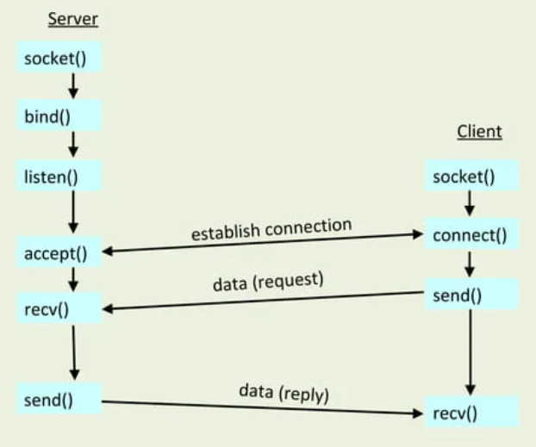

**Stages for server:**

1. **Socket creation**: the server creates the socket using ‘socket()’ function call. This returns a file descriptor.
2. **Binding:** The server binds the socket to a specific address and port using the ‘bind()’ system call. This step is essential for the server to listen for incoming connections on the specified port.
3. **Listening:** this step is used to make the server node wait and listen for connections from client node on the port and address specified by bind() function.
4. **Accept**: used to establish connection between server and client for data transfer.

**Stages for client:**

1. **Socket creation**: Similar to the server-side, the client-side also needs to create a socket using the socket() function and bind the socket to an address using the bind() function. This will create a socket that can send the connection request to the server.
2. **Connecting**: used to send the connection request and connect to the server node. The connect() system call is used to establish connection with the server.

**Closing the Connection:** Either the client or the server can initiate the closing of the connection. This is typically done by calling the close() system call on the respective socket.Closing the connection releases the associated network resources and terminates the communication session.

**Error Handling:** Throughout the connection process and data exchange, error handling is crucial. Both client and server should check for errors returned by socket-related system calls and handle them appropriately to ensure robust communication.

1. What is the use of bind() function in socket programming  ?

The bind() function is used to assign an address to a socket created using socket() function. The main function is to associate a socket with a specific network address on the local machine.

1. What is Datagram Socket ?

* A datagram socket is a type of socket used in network programming to send and receive data packets, known as datagrams, between hosts in a connectionless manner.
* Single socket to receive messages.
* No guarantee of delivery.
* No in order delivery
* Datagram are independent packets.
* Example: multimedia, VoIP